President Putin Visited by the Lord & Prayers Are Changing the World
July 17, 2016
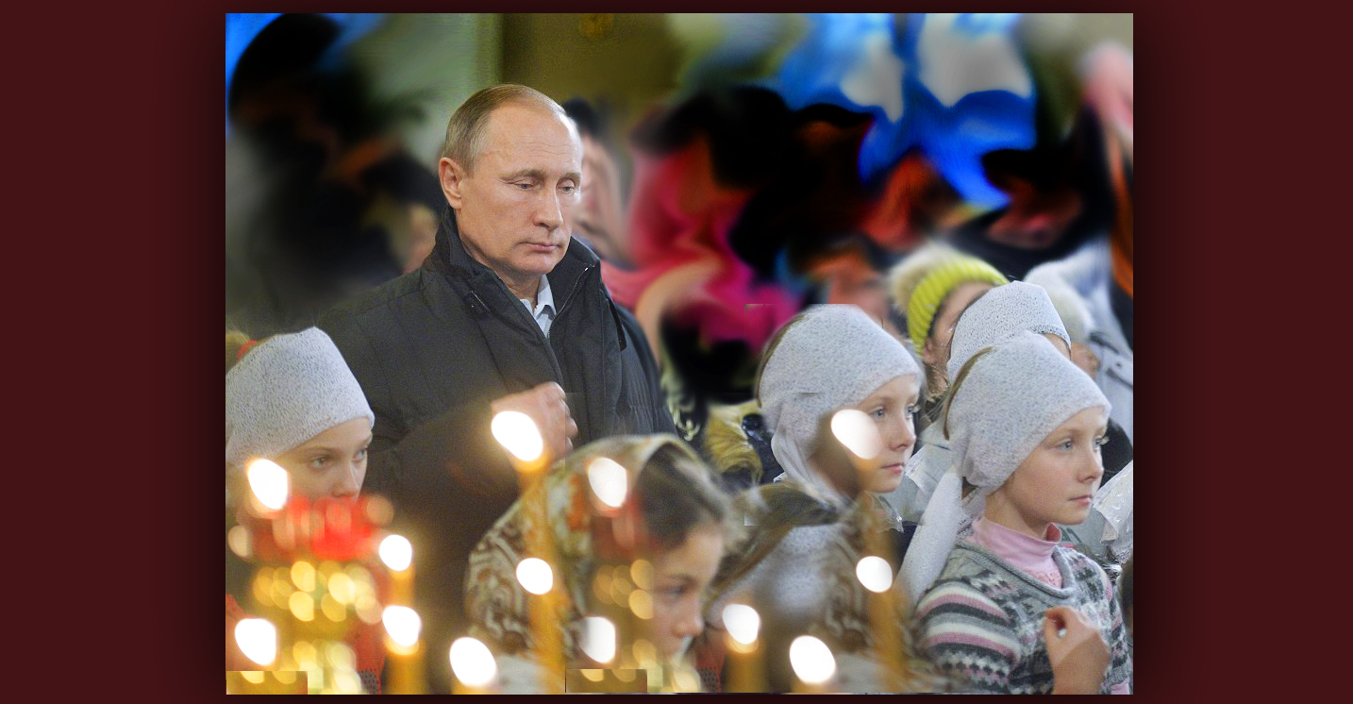
What an amazing morning today! Dear ones, the Lord is honoring your prayers; He is with us in a way more powerfully than you can ever imagine. We mustn’t stop loving or praying - this is our strength and contributing to the salvation of the world.

Today - Sunday, July 17th at 3:00 to 5:00 am mountain time, (where we are) during worship, I was taken up in the presence of the Lord Jesus and had such a burden for Pres. Putin. I sensed the glory of the Lord visiting him and I prayed that he would know how much God loves him. And I sensed he was under a burden of condemnation that was trying to hinder his thinking and peace.

Jesus began to speak, “Yes, I love him dearly and he has been chosen for such a time as this and he has responded to My overtures of love and wisdom. Now I am with him and should the whole world turn against him, nonetheless, I am still with him. 'Not by might, not by power, but by My Spirit says the Lord of hosts.'

“I raise up kingdoms and I bring them down. In My hand is the power of life and death. And those who love Me, I shall save and deliver. I have visited this man with My love, that condemnation would no longer weight him down, that his thinking would be clearer and his knowledge of who I am to him become clearer. As well as, and especially, who he is to Me. I have longed for him to know that.”

Well, dear Heartdwellers, I am not inferring that President Putin is an angel. I believe the Lord is saying that He has visited Mr. Putin with His love. And we may not be able to see the interior response that the man has, but there is one going on. So, please lets continue to pray for him.

And then the Lord continued on to address us, Heartdwellers.

“Now for you, My sweet Heartdwellers. I want you to know that Love is the golden nugget on this channel. For those who have ears to hear, understand: you are here because you were drawn to My love, by My love, and as you grow more deeply in your relationship with Me, you will love all men, as I do. This is My promise to you. And what has been begun on this Earth will surely be accomplished in its fullness in Heaven.

"If you have come here for prophecy, you are in the wrong place. Yes, I will give prophecies, but rarely. I am most concerned about love being spread throughout the Earth. When love covers the Earth like the waters cover the seas, men will live in love with one another. Of course, this will not be fully accomplished until I return to reign. But you are My ambassadors of love. And as you exercise that gift in your being, you rule and reign just as surely as if you were on a throne.

"Your prayers are over-the-top powerful to stop national crisis, change the course of history, rebuild broken alliances between countries, snuff out evil… Oh, you have NO idea how very powerful you are, My Brides. The more you love and refuse to condemn, the more your prayers have to effect change.

"Now this world is covered in the gross darkness of selfishness, greed, ambition and every evil ever conceived of by Satan. Now the world is swathed in darkness, indeed. But you are the Light of this world and that light is being passed on around the world. Yes, the torches of men in all countries have been lit by the light I have placed on this channel. And as you practice that love, you are spreading it to the darkest corners of this planet.

"That is why I do not want to see judgment or arguments on this channel. This is not a place for these things. Rather, this is the place I want people to be ignited in prayer and love. Learning to be little Lights, to be like Me - without condemnation and judgment or religious spirits. This is the place to shine forth into the world from. All of you are here because you were drawn to the light. Ignite your torches and circle the globe. Bring My unconditional love to the lost, the lonely, the disenfranchised, those rejected by religious institutions and the world.

"They, too, are My Lovers, because they have known the absolute bottom of life. They have been taken down to their lowest common denominator, unlike those who live a luxurious life in this world. They have been stripped of human dignity and even the will to live. And as they are awakened to My love, they will rise to fill the great callings they had before the beginning of time.

"The course of the world is changing, Clare. It is changing because of the prayers of the people. Christians are waking up, the ice of materialism and prosperity is beginning to melt the hearts that were frozen, and are beginning to thaw and seek the warmth of My Love, rather than the comforts of the world. Your prayers... yes, all of you! Your prayers have made a difference. The Christian leaders of the world who have shed their religious spirits have prayed as well, and a new generation of Christians is coming into their own. Christians who are done with religion, and want nothing more than to please Me, regardless of the scorn and contempt of the world.

"Oh, all of you on this channel have such an important role to play in this for the time left to you. What is not done before that fateful hour will be left behind to be completed. Know that Satan has grown desperate. He sees the souls being loosed from their traps and coming to life. He sees selfishness and materialism, power and beauty meaning less and less to the hearts of the people. He sees he is losing.

"And I am glad for it.

"But in that state, he is desperate to stop what I have begun - so hold fast to it and protect it with everything within you. Do not let men ply you with clever arguments and intellectualism, religious spirits or wicked, lying spirits of this world. Do not allow it. Guard your treasure and pass it on. Continue to pray for the world and the breaking of deadly agendas that will take souls before their time of conversion and plunge them into Hell.

"You see, as the tides turn, people wake up. Love is spread around the world, people begin to see through the shallow agendas of selfish rulers who have only their destruction in mind. People begin to see through their manipulations and agendas and they refuse to be a part of them.

"One of the graces I am now dispensing is transparency of motives. Those cloaked in deception with wicked agendas are now being exposed for what they are. And men and women have no desire to be used in this way, no desire to see their grandchildren destroyed, no desire to leave a charred planet behind, disease ridden and hopelessly suppressed by wicked rulers.

"Yes, because of the prayers of those who are waking up, the tide is indeed turning. And no matter what wicked agenda goes forward, there are thousands waking up as to how they have been used. And eventually, when I return to rule, the remnant will be ready to embrace all I teach and to live it as never before.

"So, I want to wake you all up to the effect you are having on planet Earth, you and others who are chosen. Continue praying. Continue giving. Continue loving and I will do all the rest."

As a foot note to this message, guys - I will still spend time praying and seeking the Lord. He is not saying that the Rapture is put off. He is saying that the eyes of men are being opened to the manipulation of rulers and they are fed up with it. He is asking us to spread His unconditional love and invitation to an intimate relationship in every dark corner of this world, while we are yet here.

He wants to turn the face of religion around - to make it the face of Jesus. We all have been called to this channel for a reason. Nothing is by accident; you were predestined to partake of His teachings here and spread them throughout the world. You have a mission: it begins with living unconditional love and sharing with others that your Jesus is also their Jesus - and He is calling them into His arms to be loved, healed, and become His ambassadors of love.

So don’t freak out on me…He is not putting off the Rapture. He is commissioning us to pray, because our prayers are changing the course of history, and to live His unconditional love before men.

Well, this truly was an unusual night. While I was praying and worshipping and having this beautiful experience praying for President Putin, Ezekiel was at the keyboard with headphones on recording a piano piece. When he was finished, he shared it with me. It's wonderfully pensive and has a deep nature to it. He said the Lord put Leningrad and Russia on his heart.

So here it is, "Leningrad, A Tribute To Our Russian Christian Brothers & Sisters".

The Lord bless you, Heartdwellers.

